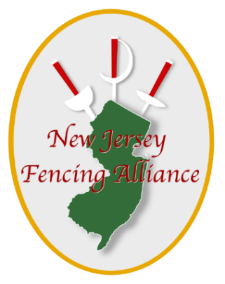
NJFA
Email: njfafrontdesk@gmail.com
Phone: (973) 762 - 6363
Address: 767 Prospect St, Maplewood, NJ 07040

Coach Request Form

Forms must be submitted at least 10 days in advance for the local competition (50 miles radius).

Local competitions (50 miles radius): $200 per fencer if there is only1 person requesting a coach, $100 if two fencers are requesting a coach and
$75 if there are three or more fencers requesting a coach for the event

Coach participation in local competitions beyond 50 miles radius is at the Club's discretion.

Before submitting the form, please make sure that you have completed all required fields. All payments should be made at the front desk.

Fencer's name: First_____________________ Last: _____________________

Email: ______________________________________________

Today’s Date: _________________________________________________

Event #1: _____________________ Event #2: __________________

Location of Competition: ___________________________ State: __________

Date of the Competition: _____________________________________

